

Practices for Secure Software Report

Table of Contents
Document Revision History 3
Client 3
Instructions 3
Developer 4
1. Algorithm Cipher 4
2. Certificate Generation 4
3. Deploy Cipher 4
4. Secure Communications 4
5. Secondary Testing 4
6. Functional Testing 4
7. Summary 4
8. Industry Standard Best Practices 4

Document Revision History

Version | Date | Author | Comments
1.0 | June 21, 2026 | Alex Hubin

Client



Instructions

Submit this completed practices for secure software report. Replace the bracketed text with the relevant information. You must document your process for writing secure communications and refactoring code that complies with software security testing protocols.

- Respond to the steps outlined below and include your findings.
- Respond using your own words. You may also choose to include images or supporting materials. If you include them, make certain to insert them in all the relevant locations in the document.
- Refer to the Project Two Guidelines and Rubric for more detailed instructions about each section of the template.

Developer
Oleksii (Alex) Hubin

Algorithm Cipher

SHA-256 is a commonly used algorithm for data integrity verification. It provides fairly strong collision resistance and so far there are no documented attacks against it that could compromise the algorithm.

The algorithm produces an output by running 64 rounds of operations that involve mixing up the data.

Certificate Generation
Insert a screenshot below of the CER file.

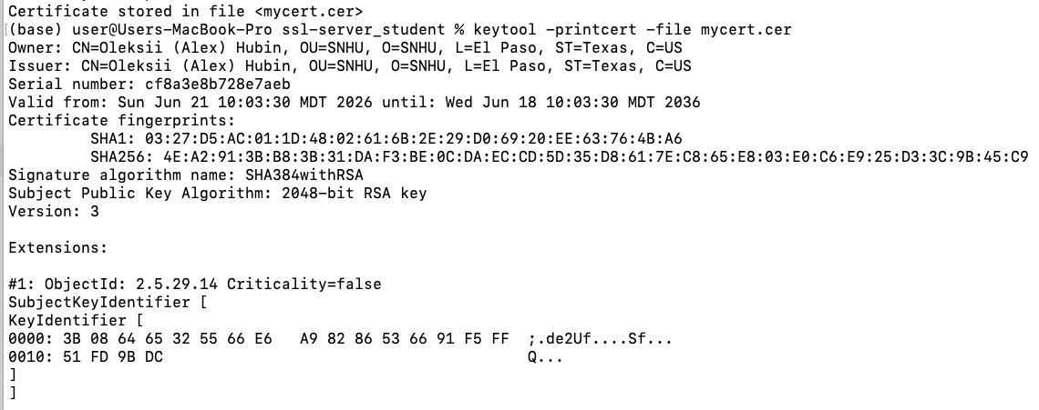

Deploy Cipher
Insert a screenshot below of the checksum verification.

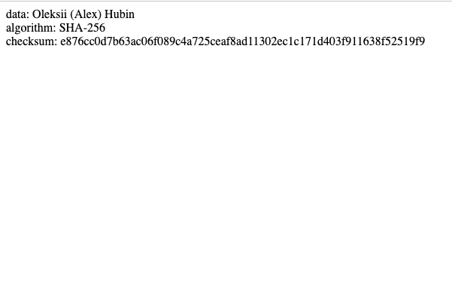

Secure Communications
Insert a screenshot below of the web browser that shows a secure webpage.

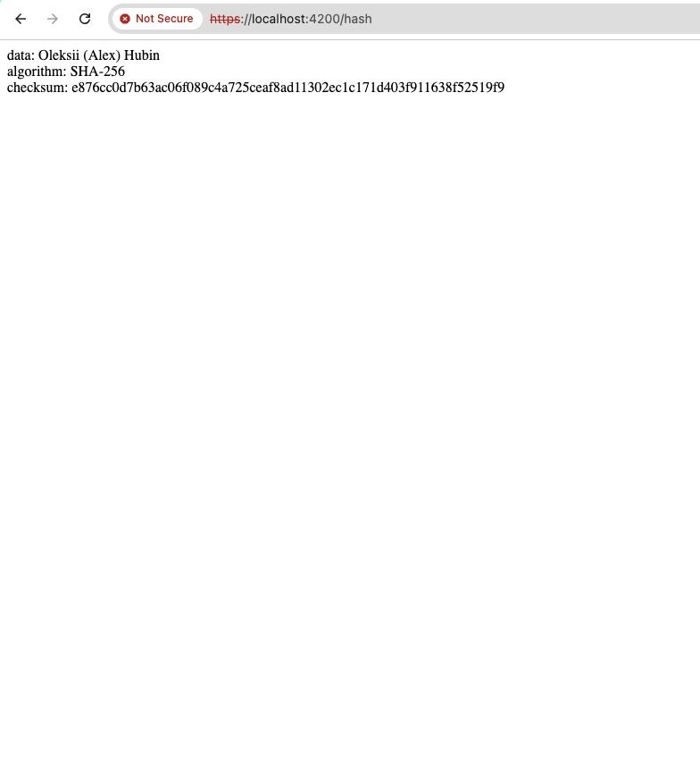

Secondary Testing
Insert screenshots below of the refactored code executed without errors and the dependency-check report.

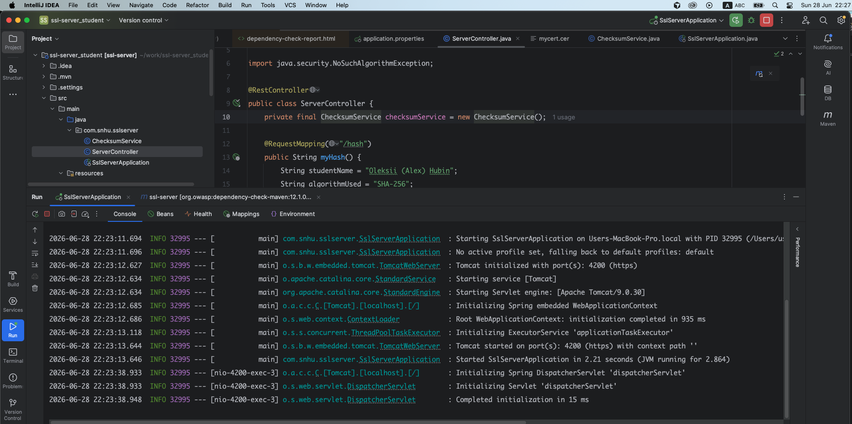

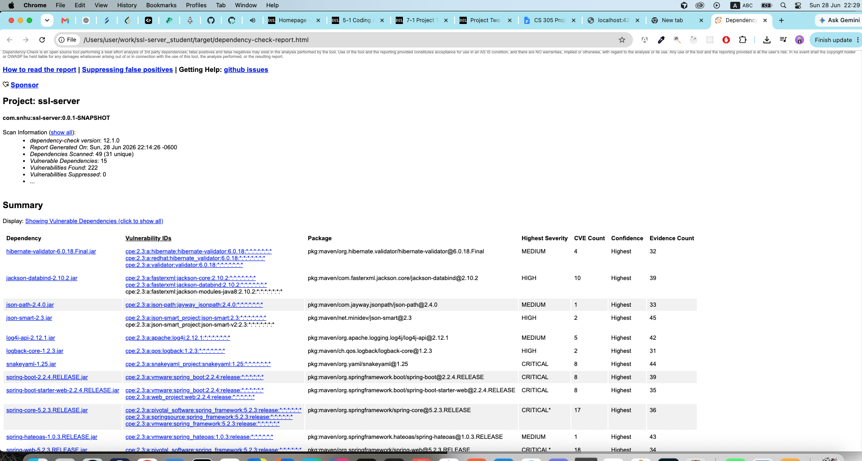

Functional Testing
Insert a screenshot below of the refactored code executed without errors.

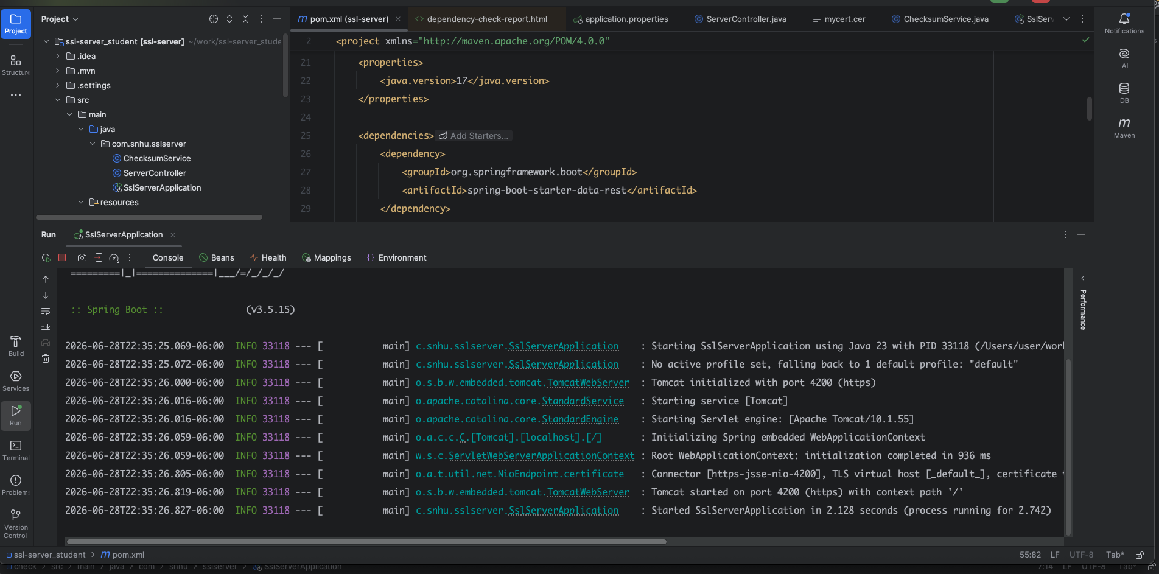

Summary

The main security issues of this project were really old versions of Java as well as Spring Boot and transient dependencies. Java 1.8 became outdated a long time ago and using it may compromise any software project.

As a result of running a dependency check with the owasp maven plugin, I decided to switch to a more modern Java 17 and spring-boot-starter-parent of version 3.5.15.

That change alone has improved the security of the project quite a bit.

Industry Standard Best Practices

- I added an SSL certificate and it established ways to switch client-server connection over to https instead of plain http.
- I used a collision-resistant SHA-256 algorithm for checksum verification and there are no documented or known attacks against the algorithm.
- I added the owasp dependency check maven plugin to analyze dependencies of this project.
- I ran a dependency check and upgraded really outdated versions of Java and Spring Boot.

